**Exercise**

**Forms And Tables**

**Q.1 Create a table referring to the image?**

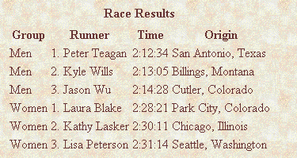

Ans-> https://github.com/maheshinder19/Training-Exercises/tree/html/forms_tables/q1

**Q.2 create a table referring to this image ?**

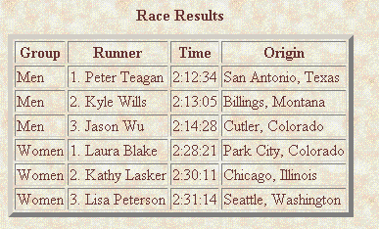

**Ans->** https://github.com/maheshinder19/Training-Exercises/tree/html/forms_tables/q2

**Q.3 Create a table and set the width to 500px . Also, keep cellspacing and cellpadding 0 ?**

Ans-> 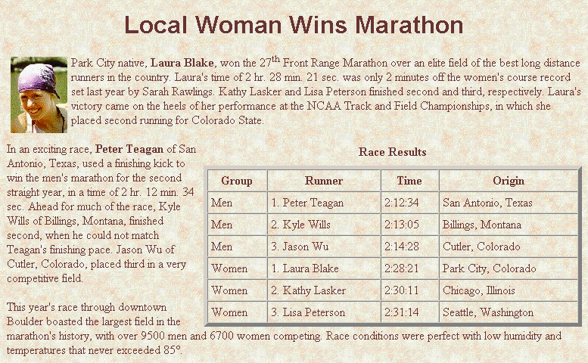

https://github.com/maheshinder19/Training-Exercises/tree/html/forms_tables/q3

**Q.4 Create a table referring to the image.**

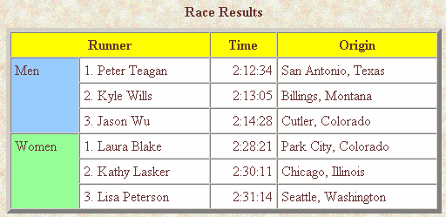

Ans->https://github.com/maheshinder19/Training-Exercises/tree/html/forms_tables/q4

**Q.5 create a webpage using nested tables ?**

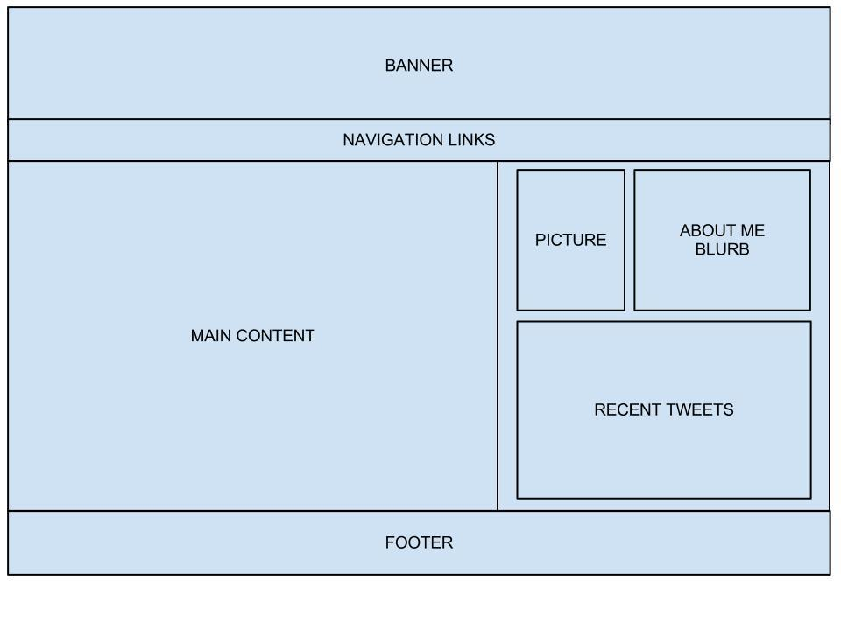

https://github.com/maheshinder19/Training-Exercises/tree/html/forms_tables/q5

**Q.6 Create a form like this ?**

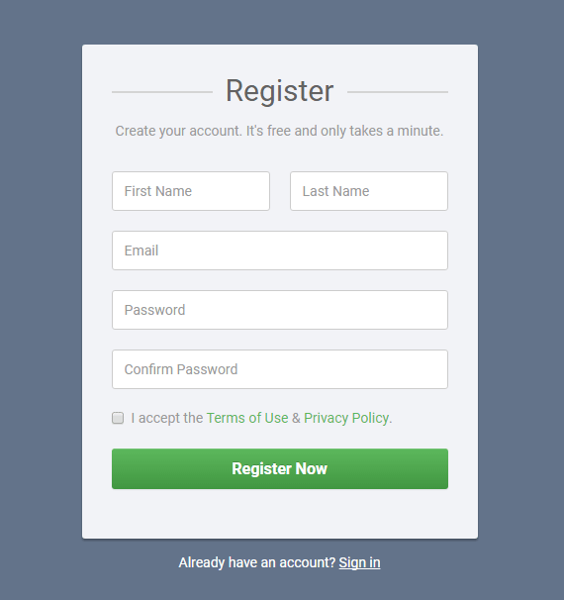

Ans->

https://github.com/maheshinder19/Training-Exercises/tree/html/forms_tables/q6